You need in eclipse:

* WTP plugin
* GWT plugin

project settings:

1)

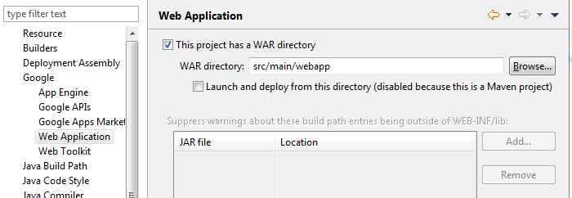

2)

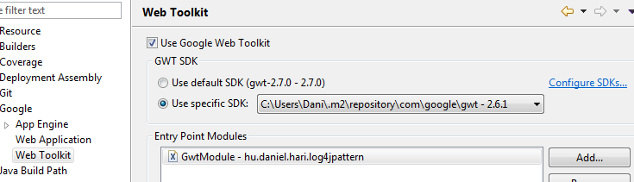

3)

Every time after you runned UPDATE MAVEN PROJECT do the following:

- Project properties --> Deployment assembly --> find the line: "m2e-wtp" --> REMOVE THE LINE

(otherwise you will suffer jetty file unsynchronizing problem)

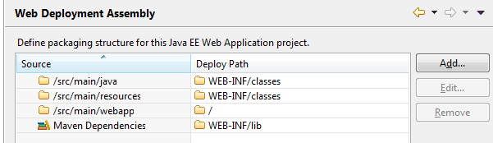

generate target dir, build war:

run as -> Maven Build… -> goal: package

Debug Configurations:

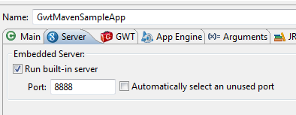

Maintain arguments if something is not correct:  
(war should point to your ..\target\gwt-webapp directory)

-war **d:\work\wsNVT\.TestProjects\SampleGwtMaven\target\gwt-webapp** -remoteUI "${gwt_remote_ui_server_port}:${unique_id}" -startupUrl GWTTest1.html -logLevel INFO -codeServerPort 9997 -port 8888 hu.ponte.gwttest.GWTTest1

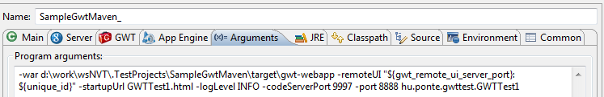

log4j gwt devmode conflict workaround - add vm argument:

-Dlog4j.ignoreTCL=true

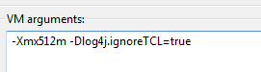

For classic dev mode you can only use Firefox 24.0   
(newer version and chrome does not support gwt plugin anymore)  
A download link: <http://pcforum.hu/letoltes/3029/firefox+24.html>